>>>>>>>>
Travis 'Bike' Motor Manual

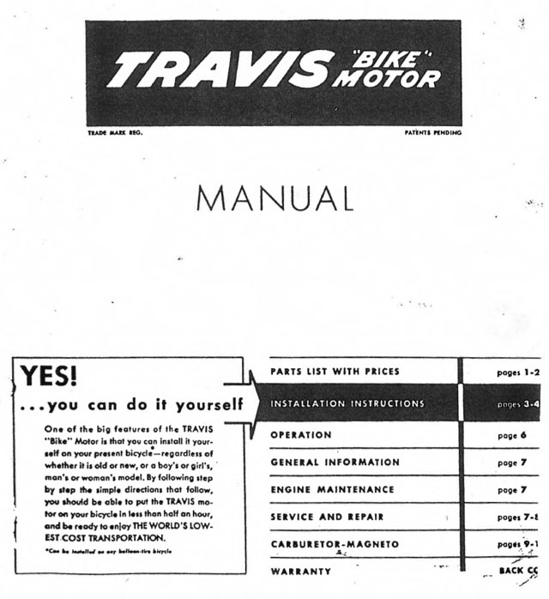
>>>>>>>>
Parts
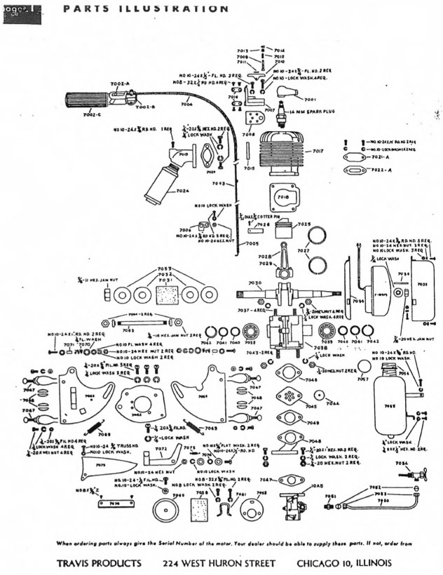
>>>>>>>>

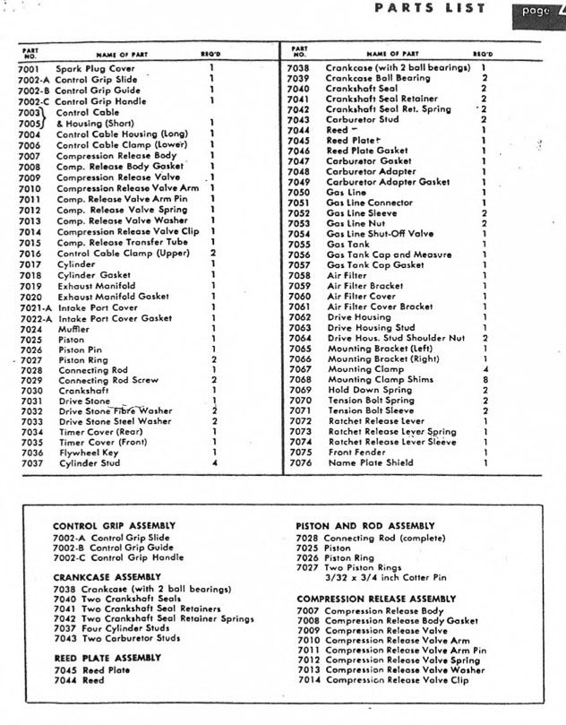
>>>>>>>>
Installation Instructions
Fig 1
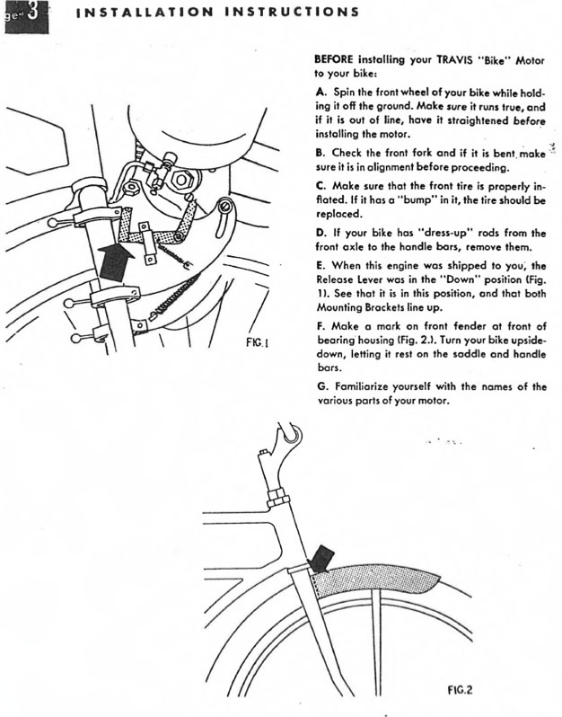
>>>>>>>>
Installation Instructions (cont)

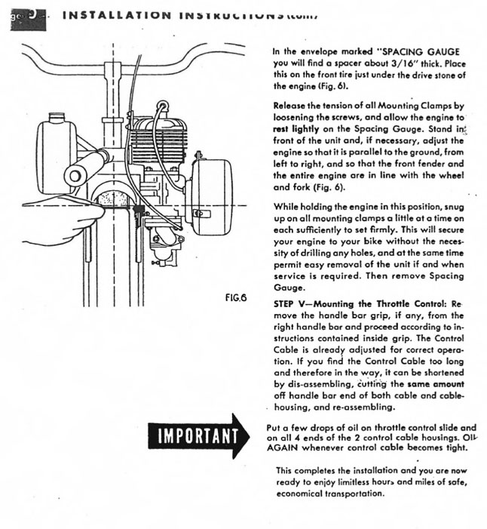
>>>>>>>>
Parts
Figs 4,5

>>>>>>>>
Installation Instructions
Figs 3,4,5:
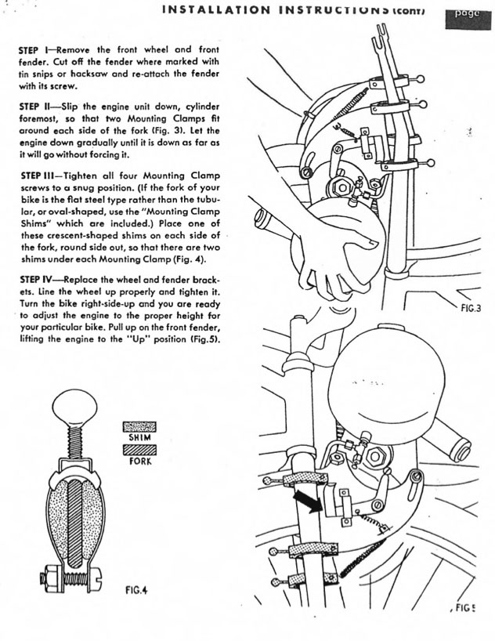
>>>>>>>>
Operation
Fig 8
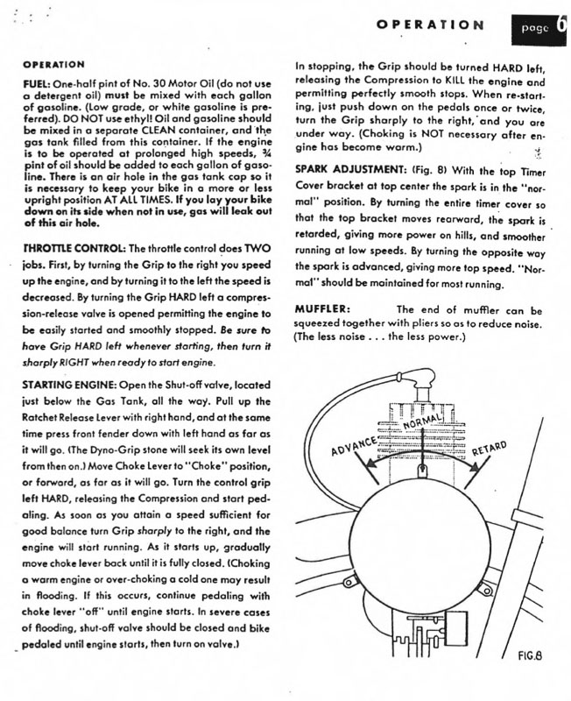
Tillotson Carburetor Model MT-8A
>>>>>>>>
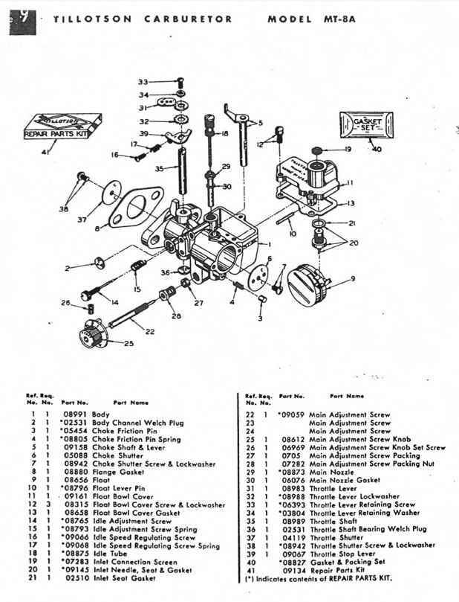
>>>>>>>>
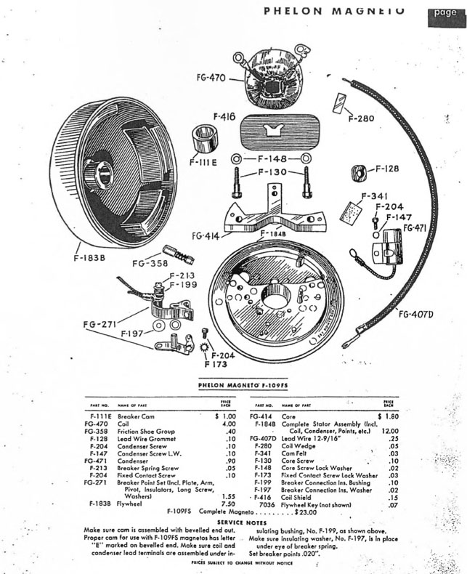
>>>>>>>>
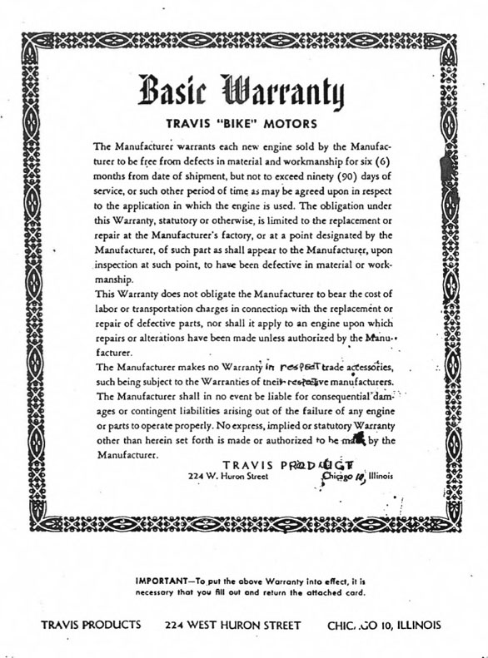
>>>>>>>>

More or less Familiar Travis Bike Motor Instances





